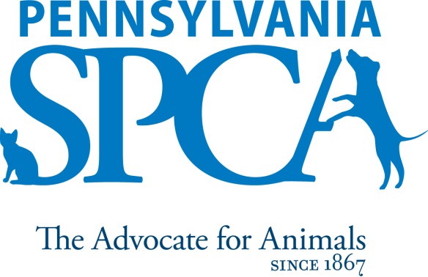

Lancaster - Animal Care Attendant

Implemented 8/17, FLSA Status: Non-Exempt

THE ORGANIZATION The Pennsylvania Society for the Prevention of Cruelty to Animals (Pennsylvania SPCA) is a non-profit animal welfare organization that has been working to protect and improve the lives of animals since its founding in 1867. It is the second oldest humane organization in the United States. The organization employs 130 staff and operates two animal sheltering and adoption facilities. With programs ranging from rescuing animals from abuse to low-cost veterinary services and pet adoption, the Pennsylvania SPCA is the largest animal welfare organization in Pennsylvania and the mid-Atlantic region.

SUMMARY: The Animal Care Attendant will be responsible for providing compassionate and attentive care to the animals housed at the Lancaster, Pennsylvania Animal Shelter at all times, assisting adopters and maintaining a clean healthy environment for the animals and the public, and helping with other duties as needed.

PRINCIPAL DUTIES
- Follows all policies and procedures as well as working effectively, efficiently and in accordance with the organization’s policies.
- Performs daily, thorough cleaning of all animal areas and spot cleaning of animal and public areas throughout the day.
- Feeds and provides water for the animals, including providing special diets as needed.
- Socializes and grooms the animals as needed.
- Keeps animal records current with information which will help place them into suitable homes, foster homes or rescue.
- Enters medical examinations and behavior notes in Petpoint as needed.
- Doing laundry, dishes, washing windows, cleaning and mopping public and shelter areas as needed.
- Maintains a healthy, safe, clean and pleasant environment and facilities for the animals and the public.
- Provides transportation for animals as needed.
- Treats all animals humanely, properly, and with compassion at all times, regardless of the situation or circumstance.
- Assists in the vaccination, examination, performance of medical treatments and euthanasia as needed.
- Works courteously and cooperatively with other staff members and management.
- Refills supplies as needed.
- Provides high quality customer service to people who visit or call the Pennsylvania SPCA.
- Uses shelter management software to effectively and efficiently track animals coming to and going from the shelter.
- Monitors the health of the animals in the shelter, and entering the shelter, on an ongoing basis by rapidly identifying any health problems or conditions (medical or behavioral) and immediately reporting them to the supervisor.
- Works effectively as part of a team on cross-functional programs, projects, and activities as well as courteously and cooperatively with other staff members.
- Assists the Site Supervisor with his or her work as needed.
- Filling in for other areas and performing other tasks/functions as needed, including helping out at special events.

EDUCATIONAL REQUIREMENTS
High School Diploma or equivalent. Valid Driver’s License preferred.

EXPERIENCE, ABILITIES AND QUALITIES REQUIRED
- Strong interpersonal skills. The ideal person for this job would be personable, outgoing, patient, professional, and able to get along well with a variety of people.
- Affection for animals, concern for their welfare, and a willingness to accommodate animals in the work place.
- Maturity, good judgment and a professional personal appearance.
- Patient restraint: restraint of non-fractious and fractious or fearful animals for vaccines/injections, cephalic blood draw, anal gland/ear assessment and microchipping.
- Strong problem solving skills – focusing on finding solutions to problems and challenges.
- Strong organizational and computer skills.
- The ability to remain pleasant and calm even in stressful situations.
- The ability to ask appropriate questions to gather information along with the ability to feel and show empathy for others.
- Flexibility, ability to manage multiple tasks.
- Ability and initiative, work with minimal supervision and direction.
- Knowledge of animal behavior and common medical conditions. (Or a willingness to rapidly gain this knowledge.)
- Comfort and ability in working with animals of unknown disposition and those who may exhibit medical and other problems, as well as aggressive tendencies.
- Ability to accommodate varied work assignments and schedules.
- Ability to lift and move objects and animals weighing up to 50 pounds for short distances and to humanely restrain an animal when necessary.
- Must be able to drive all PSPCA vehicles including but not limited to tractor, trailer, RV and conversion sprinter.
- Must have a sincere interest in the work, programs and mission of the Pennsylvania SPCA
IMMEDIATE SUPERVISOR Site Manager
HOURS FLSA STATUS: NON-EXEMPT POSITION Minimum of 8 hours per day, 37.5 hours per week. Daily hours and days of the week may vary according to the needs of the department schedule. Includes weekend, night, holiday, overnight, and on-call work.
INTRODUCTORY ASSESSMENT PERIOD The introductory assessment period runs from the date of hire for three months thereafter. For employment in any position with the Pennsylvania SPCA, this introductory assessment period is the period during which the specifics of the job are learned. During this period, either the employee or the Pennsylvania SPCA may end the employment relationship without notice or prejudice.
EMPLOYMENT There is no minimum period of employment guaranteed or implied by acceptance of an employment offer. It is the policy of Pennsylvania SPCA that even exempt positions are governed by the needs of the agency, which means that employment is for no specified term and either the Pennsylvania SPCA or the employee, may terminate that employment at any time. The Chief Executive Officer has final authority over these decisions and determinations.

.

