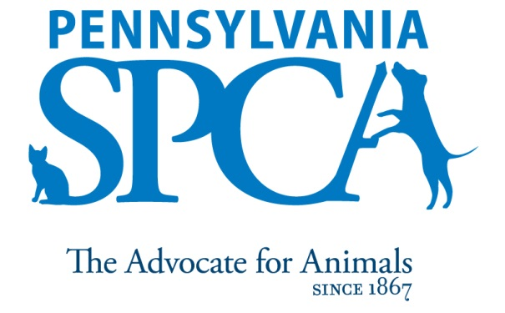
JOB DESCRIPTION

STAFF VETERINARIAN/ WELLNESS CLINIC, ERIE AVENUE

SUMMARY: The Pennsylvania SPCA wellness clinic offers low cost, high quality veterinary care to the public on a walk in bases. The wellness clinic offers routine preventive exams, sick or medical exams, geriatric and end of life care. The clinic offers a full laboratory, in house blood work, reference laboratory (Antech), pharmacy, and new state of the art digital x-ray machine. The wellness clinic is intended to be a community service that treats and releases animals. We do not provide hospitalization or emergency care. Staff veterinarians will be primarily responsible for performing all aspects of veterinary work including exams, tests, procedures and maintaining proper record keeping for client owned animals in a wellness clinic.
PRINCIPAL DUTIES

- High volume wellness and sick visits to the public on a walk in basis which includes diagnosing, treating and performing follow-up care.
- Work within the means of the patient’s caregiver while maintaining the best possible care at the most cost efficient price.
- Make recommendations when funds might not be able to support ideal treatment.
- Maintain excellent patient, client and veterinary relationship
- Implement, maintain, refine and follow all medical policies and procedures, keeping abreast of contemporary veterinary medical practices and adhering to applicable veterinary laws and PSPCA polices.
- Provide accurate and efficient recordkeeping of veterinary care provided to animals in our patient management software (Cornerstone)
- Direct support staff (technicians and assistants) to perform duties specified to the veterinarians needs.
- Provide follow up care for fostered or recently adopted animals;
- Work courteously and cooperatively with staff and volunteers to ensure that all established procedures and policies of the Pennsylvania SPCA are followed; follow established procedures governing safe work practices including, but not limited to, wearing protective clothing and/or equipment when necessary; perform duties in a manner which encourages attainment of goals, contributions and business for the Pennsylvania SPCA and its programs;
- Work closely with volunteers, veterinarians and veterinary students to expand the Pennsylvania SPCA’s capacity for care and treatment; including but not limited to overseeing veterinary student externs
- Assist when needed in other departments or locations;
- The intent of this job description is to provide a representative and level of the types of duties and responsibilities that will be required of positions given this title and shall not be construed as a declaration of the total of the specific duties and responsibilities of any particular position. Employees may be directed to perform job-related tasks other than those specifically presented in this description.

EDUCATIONAL REQUIREMENTS Veterinary licensure in the State of Pennsylvania or licensure in another state with the intent and ability to gain licensure in the State of Pennsylvania. Knowledge of, interest and passion in, or continuing education performed in the field of shelter medicine, high-quality, high-volume spay/neuter and high-volume, low-cost veterinary medicine.

EXPERIENCE, ABILITIES AND QUALITIES REQUIRED
- Ability to problem solve and work with minimal supervision. Affection for animals and concern for their welfare.
- Experience in caring for and handling animals in a safe, effective and humane manner, especially larger and possibly untrained animals. Knowledge of contemporary shelter maintenance techniques and accepted sanitary practices. Knowledge of various breeds and their characteristics and familiarity with symptoms of diseases common to dogs and cats. Knowledge of preventive, diagnostic and therapeutic veterinary treatment of domestic animals.
- Ability to accommodate varied work assignments and schedules. Ability to provide leadership and direction to employees and volunteers. Ability to communicate skillfully and effectively with a culturally diverse staff, volunteers and community in a professional, pleasant, respectful, courteous and tactful manner at all times. Maturity, good judgment and professional personal appearance including the wearing of neat and clean uniforms.
- Ability to lift and move objects and animals weighing up to 50 pounds for short distances and to humanely restrain an animal when necessary.
- Comfort and ability to work with animals of unknown disposition and those who may exhibit medical and other problems, as well as aggressive tendencies.
- Valid driver’s license with no record of convictions.
IMMEDIATE SUPERVISOR Head of the Wellness
HOURS Daily hours and days of the week may vary according to the needs of the department schedule. Includes weekends, and on-call work.
INTRODUCTORY ASSESSMENT PERIOD The introductory assessment period runs from the date of hire for sixty days thereafter. For employment in any position with the Pennsylvania SPCA, this introductory assessment period is the period during which the specifics of the job are learned.
EMPLOYMENT There is no minimum period of employment guaranteed or implied by acceptance of an employment offer. It is the policy of Pennsylvania SPCA that even exempt positions are governed by the needs of the agency, which means that employment is for no specified term and either the Pennsylvania SPCA or the employee, may terminate that employment at any time. The Chief Executive Officer has final authority over these decisions and determinations.

