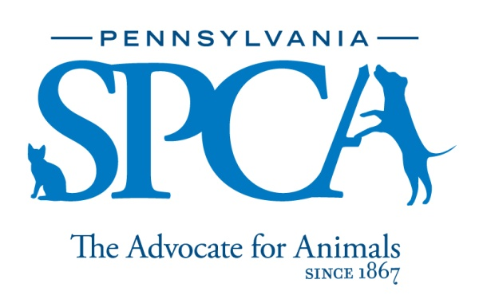

Mainline Veterinarian

The PSPCA is a non-profit animal welfare organization founded in 1867. Our mission is to protect animals, prevent cruelty and improve the health and quality of life for animals in Pennsylvania.

SUMMARY: The Veterinarian at the Mainline Site is responsible for the medical care of all shelter animals. Veterinary care is administered for the purpose of providing shelter, quarantine, placement, disposition of animals. The intent of this job description is to provide a representative and level of the types of duties and responsibilities that will be required of positions given this title and shall not be construed as a declaration of the total of the specific duties and responsibilities of any particular position. Employees may be directed to perform job-related tasks other than those specifically presented in this description.

PRINCIPAL DUTIES

- Manage the medical care of animals housed at the Mainline location
- Medical care may be necessary for any shelter animals (including those at the Philadelphia, Danville and Lancaster locations)
- Perform diagnostics and implement treatment plans for sick and injured shelter animals
- Perform castrations/OHEs prior to release to new owners
- Perform dentals and mass removals
- Attend and oversee vaccine clinics
- Prevent and control disease in the shelter animal population
- Provide clinical supervision of technicians administering vaccinations and treatments
- Serve as a resource with animal health related issues
- Serve as a member of a team to assist the Medical Director in decisions on shelter procedures and policies
- Work directly with the Clinic Manager to manage medical/surgical inventory for veterinary services
- Work with Clinic and Shelter Manager to ensure all necessary state required paperwork and information is ready for unannounced inspection
- Enter animal medical records and information into Pet Point and Cornerstone when necessary
- Perform live animal forensic exams and necropsies for humane law enforcement (HLE) animals. This includes but is not limited to crime scene processing, evidence collection and handling, crime scene/live animal photography, live examinations and necropsy, emergency care, vaccinations, and intakes
- Attend court as an actual and expert witness when required for HLE cases
- Maintain confidentiality of evidence/records/case information at all times
- Manage controlled substances

EDUCATIONAL REQUIREMENTS: Veterinary licensure in the State of Pennsylvania or licensure in another state with the intent and ability to gain licensure in the State of Pennsylvania. Ideally have five (5) years experience as a veterinarian, preferably in a shelter environment. Must hold or be willing to hold a DEA license.

EXPERIENCE, ABILITIES AND QUALITIES REQUIRED:
- Knowledge of or continuing education performed in the field of shelter medicine, forensic veterinary medicine, high-quality, high-volume spay/neuter and high-volume, low-cost veterinary medicine
- Ability to problem solve and work with minimal supervision. Affection for animals and concern for their welfare
- Experience in caring for and handling animals in a safe, effective and humane manner, especially larger and possibly untrained animals. Knowledge of contemporary shelter maintenance techniques and accepted sanitary practices. Knowledge of various breeds and their characteristics and familiarity with symptoms of diseases common to dogs and cats. Knowledge of preventive, diagnostic and therapeutic veterinary treatment of domestic animals
- Ability to accommodate varied work assignments and schedules. Ability to provide leadership and direction to employees and volunteers. Ability to communicate skillfully and effectively with a culturally diverse staff, volunteers and community in a professional, pleasant, respectful, courteous and tactful manner at all times. Maturity, good judgment and professional personal appearance including the wearing of neat and clean uniforms
- Ability to lift and move objects and animals weighing up to 50 pounds for short distances and to humanely restrain an animal when necessary
- Comfort and ability to work with animals of unknown disposition and those who may exhibit medical and other problems, as well as aggressive tendencies

HOURS: Daily hours and days of the week may vary according to the needs of the department schedule. Includes weekends, night, holiday and on-call work.

INTRODUCTORY ASSESSMENT PERIOD: The introductory assessment period runs from the date of hire for sixty days thereafter. For employment in any position with the Pennsylvania SPCA, this introductory assessment period is the period during which the specifics of the job are learned.

EMPLOYMENT: There is no minimum period of employment guaranteed or implied by acceptance of an employment offer. It is the policy of Pennsylvania SPCA that even exempt positions are governed by the needs of the agency, which means that employment is for no specified term and either the Pennsylvania SPCA or the employee, may terminate that employment at any time. The Chief Executive Officer has final authority over these decisions and determinations.
The Pennsylvania SPCA is an equal opportunity employer.

