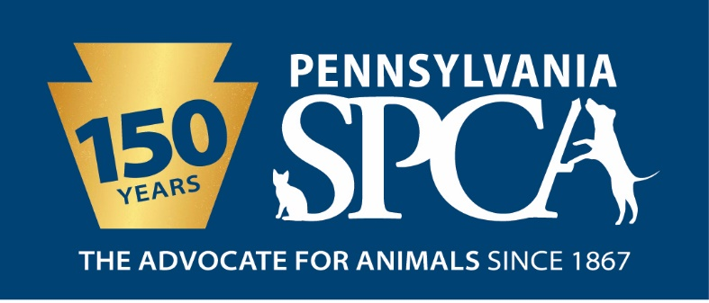
JOB DESCRIPTION
VETERINARY NURSE- MAIN LINE ANIMAL RESCUE LOCATION
FLSA Status: Non-Exempt
SUMMARY The Veterinary Nurse will be primarily responsible for assisting the veterinarians, managers and customer service staff in all duties relating to the veterinary care of animals in the clinic and shelter as assigned. Veterinary nurses must have a broad knowledge of animal science and medicine including a basic knowledge of pharmacology and sufficient mathematical skills to ensure the administration of accurate drug and fluid doses. These responsibilities will vary with the current needs of the clinic and shelter staff, the season of the year, the facility location, and the individual abilities demonstrated by the employee.
PRINCIPAL DUTIES
- Communicate exam findings and provide direct support to the veterinarian with client and shelter animals.
- Complete thorough medical examinations working with veterinarians and nursing assistants.
- Read and interpret medical records to determine vaccination status and medication needs.
- Performing and assisting with vaccinations of non-fractious and fractious or fearful animals upon intake
- Examination and care of sick shelter animals including cage cleaning, exercising, feeding, observing animals for illness, following disease prevention protocols, knowledge of common diseases, their symptoms and means of transmission, laundry and bathing.
- Performing and working cooperatively with other staff members to accomplish the general cleaning of all areas to maintain a clean odor free clinic and shelter; maintain clinic and surgical equipment such as microscopes and surgical packs; assist in maintaining healthy, safe, sanitary, pleasant and clean facilities for the animals under the care of Main Line Animal Rescue at all times.
- Performing and assisting with euthanasia.
- Perform, read and interpret laboratory tests, complete forms for out-of-house laboratory, filing and scanning of laboratory tests, cleaning up of laboratory areas, data entry
- Admit and release animals in a responsive, courteous and tactful manner and through managed recordkeeping, inform volunteers, staff, and the public of any pertinent medical information on the animal's care; assist staff and volunteers whenever necessary to assure smooth, courteous handling of the public and their pets.
- Work courteously and cooperatively with staff and volunteers to ensure that all established procedures and policies of Main Line Animal Rescue are followed; follow established procedures governing safe work practices including, but not limited to, wearing protective clothing and/or equipment when necessary; perform duties in a manner which encourages attainment of goals, contributions and business for the Main Line Animal Rescue and its programs.
- Treat people and animals with respect; contribute to effective teamwork; and foster public relations beneficial to Main Line Animal Rescue and its programs; promote a humane and caring attitude toward all animals and treat all animals humanely, properly and with compassion at all times, regardless of circumstances including those that are sick, injured, feral or aggressive.
- Assist when needed in the shelter, clinic, surgery, critical care unit or other department or location.
- Perform all duties of veterinary technician as required.
- The intent of this job description is to provide a representative and level of the types of duties and responsibilities that will be required of positions given this title and shall not be construed as a declaration of the total of the specific duties and responsibilities of any particular position. Employees may be directed to perform job-related tasks other than those specifically presented in this description.

AS A VETERINARY NURSE YOU WILL BE EXPECTED TO KNOW THE FOLLOWING:
- Medication administration: oral, topical, aural, ocular, subcutaneous and intravenous.
- Equipment use: fluid pump, centrifuge, refractometer, heating pads, pulse ox ecg, cbc/chem machine, microscope, glucometer and nebulizer.
- Patient Monitoring: TPR/CRT/MM color assessment, anesthetic depth, heart rate, pulse quality, maintaining charts properly, post-surgical assessment, hydration.
- Medical Care: feeding amounts, cleanliness, minor wound bandaging, suture/staple removal, ear cleaning/flushing, triage patients and therapeutic bathing
- Medical Records: scan in and attach medical records, update records for weights, data, pictures, properly log history and client communication and enter notes as directed by veterinarian.
- Pharmacology: prescription labels, proper routes of administration, proper handling and storage of drugs, can convert mg dosing to ml volume for treatment, dose calculations, reconstitute and label IV properly.
- Medical Terminology: vaccine protocols, parasite preventives, retrovirus risks and testing protocol and heartworm testing protocol
- Laboratory skills: read direct fecal float and smear, read fecal cytology, read skin scrape, read urine sediment, set up blood smear and stain, set up/read gram stains of ear/skin samples, knowledge of blood tubes, perform PCV/TS, able to run dilution for chem machine when needed, run snap screen for combo, 4dx, parvo etc., prepare antech/idexx forms and samples.
- Radiology Skills: develop radiographs, understand radiology safety, know how, why and where to measure, handling of cassettes and film, provide diagnostic xrays, stock and maintain equipment and supplies.
- Patient restraint: restraint of non-fractious and fractious or fearful animals for vaccines/injections, cephalic blood draw, anal gland/ear assessment and microchipping.
- Understand aseptic principles and apply them to surgical patients, instruments,
equipment and rooms.
- Know the names of instruments and where they are stored.
- Prepare the surgery suite(s) for incoming patients.
- Prepare patients for surgery. Clip surgical fields with straight margins. Minimize tissue
trauma. Properly scrub and prepare surgical fields. Maintain clean fields when moving
patients.
- Properly position and align patients for surgery.
- Assist surgeons with aseptic gowning and gloving.
- Anticipate surgeons’ needs for assistance, instruments, and patient monitoring (and
treatments).
- Monitor patients’ recoveries. Protect patients from aspiration and hypothermia. Deflate
cuffs and remove endotrachael tubes as soon as gag reflexes return.
- Maintain surgery logs with patients’ names, doctors’ names, procedures performed,
types and amounts of preanesthetic and anesthetic agents, and surgical times.
- Keep controlled drugs secured to meet DEA and state board specifications as well as
drug logs.
- Update patient records with drugs administered, procedures performed, and patient
status during surgeries and recoveries.
- Dentistry skills: identify and stage dental disease, aware of canine and feline dental formula, can teach owners proper home care and perform dental cleaning/polishing.

EDUCATIONAL REQUIREMENTS AND QUALIFICATIONS
- Minimum High School diploma or GED required; some college, trade, vocational school, college or further education preferred.
- Must be proficient using computer. Knowledge of Internet, Microsoft Word and Excel required, knowledge of Pet Point Animal Management System, VIA software and web based software a plus.
- CVT or minimum of three years of experience in the veterinary field working as a veterinary assistant or technician.

EXPERIENCE, ABILITIES AND QUALITIES REQUIRED
- Ability to problem solve and work cooperatively in a team environment; affection for animals and concern for their welfare.
- Comfort and ability to work humanely with animals of unknown disposition and those who may exhibit medical and other problems, as well as aggressive tendencies.
- Ability to accommodate varied work assignments and schedules.
- Ability to communicate skillfully and effectively with a culturally diverse staff, volunteers and community in a professional, pleasant, respectful, courteous and tactful manner at all times.
- Maturity, good judgment and professional personal appearance including the wearing of neat and clean uniforms.
- Physical strength and ability to lift and carry a pet or other object weighing up to fifty (50) pounds without assistance; must be able to assist in lifting patients or other objects weighing more than fifty (50) pounds.
IMMEDIATE SUPERVISOR Director of Veterinary Services
HOURS FLSA STATUS: NON-EXEMPT POSITION Full-time position requires eight (8) hours per day, forty (40) hours per week. Part-time position hours are dictated by the needs of the organization. Daily hours and days of the week (for both full and part-time positions) may vary according to the needs of the department schedule. Includes weekends, night, and holiday work.
INTRODUCTORY ASSESSMENT PERIOD The introductory assessment period runs from the date of hire for three months thereafter. For employment in any position with the Pennsylvania SPCA, this introductory assessment period is the period during which the specifics of the job are learned. During this period, either the employee or the Pennsylvania SPCA may end the employment relationship without notice or prejudice.
EMPLOYMENT There is no minimum period of employment guaranteed or implied by acceptance of an employment offer. It is the policy of Pennsylvania SPCA that even exempt positions are governed by the needs of the agency, which means that employment is for no specified term and either the Pennsylvania SPCA or the employee, may terminate that employment at any time. The Chief Executive Officer has final authority over these decisions and determinations.

