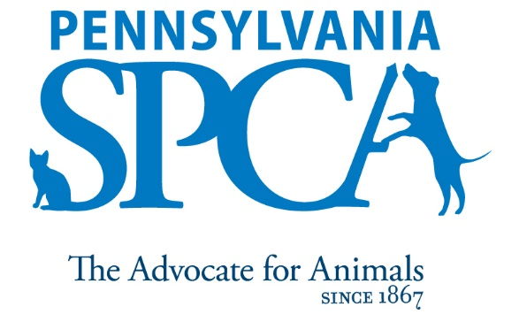
JOB DESCRIPTION
Humane Law Enforcement Dispatcher

1/2018, FLSA Status: Non- Exempt

SUMMARY: The Humane Law Enforcement Dispatcher is responsible for receiving, prioritizing, transferring and dispatching to the appropriate personnel animal cruelty calls regarding complaints about abused, ill-treated animals, animal fighting, and general information request. The dispatcher also responds to public inquires and explains the law and ordinances related to animal cruelty and refers calls to other agencies when appropriate. The intent of this job description is to provide a representative and level of the types of duties and responsibilities that will be required of positions given this title and shall not be construed as a declaration of the total of the specific duties and responsibilities of any particular position. Employees may be directed to perform job-related tasks other than those specifically presented in this description.

PRINCIPAL DUTIES
Complying with State Laws, receives, prioritizes, transfers, and dispatches to the appropriate personnel animal cruelty calls regarding complaints about abused and ill treated animals, animal fighting and general information requests. Maintains computer records and files of all complaints. Performs data entry and query of animal cruelty history on computers, and assists officers in locating addresses, following up with complainants and maintaining confidentiality of records.

Responds to public inquiries and explains departmental policies and the laws and ordinances related to animal control in city of Philadelphia, PA animal regulatory laws and anti-cruelty statutes statewide. Refers calls to other agencies when appropriate.

Responds to animal related complaints and collects necessary information on validity of complaints, location, nature of incident and status and assigns the complaint to the humane officer working in the service area of the complaint.

Communicates with officers via cellular phones. Relays complaint information to officers, providing the necessary information including nature and location of complaint, owner information, and any history of complaints.

Documents complaints in computer using PetPoint or other assigned software, accurately completes complaint information as thoroughly as possible.

Uses the computer to create new forms and documents for office, officer and dispatcher use.
Gathers information at officers’ request using maps, books, computer programs, or through police agencies.

Other tasks as assigned through department including but not limited to assisting officers in field.

EDUCATIONAL REQUIREMENTS

High School Diploma or equivalent.

EXPERIENCE, ABILITIES AND QUALITIES REQUIRED
- Strong interpersonal skills. Personable, outgoing, patient, professional, and able to get along well with a variety of people.
- Strong written and verbal skills, including the ability to communicate skillfully and effectively with a culturally diverse staff, volunteers and community in a professional, pleasant, respectful, courteous and tactful manner at all times.
- Strong problem solving skills – focusing on finding solutions to problems and challenges.
- Strong organizational and computer skills.
- Able to communicate and speak in Spanish
- Able to remain pleasant and calm even in stressful situations.
- Able to ask appropriate questions to gather information along with the ability to feel and show empathy for others.
- Flexibility the ability to manage multiple tasks.
- Knowledge of animal behavior and common medical conditions (or a willingness to rapidly gain this knowledge.)
- Comfort and ability in working with animals of unknown disposition and those who may exhibit medical and other problems, as well as aggressive tendencies.
- Ability to lift and move objects and animals weighing up to 50 pounds for short distances and to humanely restrain an animal when necessary.
- Prior knowledge and experience with Microsoft, Excel and data management programs.
- Must have a sincere interest in the work, programs and mission of the Pennsylvania SPCA
IMMEDIATE SUPERVISOR Director of Humane Law Enforcement
HOURS FLSA STATUS: NON- EXEMPT POSITION Minimum of 8 hours per day, 40 hours per week. Daily hours and days of the week may vary according to the needs of the department schedule. Includes weekends, night, holiday and on-call work.
INTRODUCTORY ASSESSMENT PERIOD The introductory assessment period runs from the date of hire for three months thereafter. For employment in any position with the Pennsylvania SPCA, this introductory assessment period is the period during which the specifics of the job are learned. During this period, either the employee or the Pennsylvania SPCA may end the employment relationship without notice or prejudice.
EMPLOYMENT There is no minimum period of employment guaranteed or implied by acceptance of an employment offer. It is the policy of Pennsylvania SPCA that even exempt positions are governed by the needs of the agency, which means that employment is for no specified term and either the Pennsylvania SPCA or the employee, may terminate that employment at any time. The Chief Executive Officer has final authority over these decisions and determinations.
The Pennsylvania SPCA is an equal opportunity employer.

