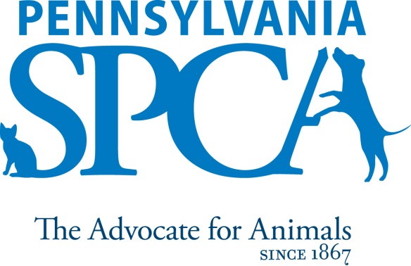

Spay/Neuter and
Shelter Veterinarian

The Pennsylvania SPCA is a non-profit animal welfare organization founded in 1867. Our mission is to protect animals, prevent cruelty and improve the health and quality of life for animals in Pennsylvania.

SUMMARY: The Pennsylvania SPCA is seeking an experienced veterinary surgeon and shelter vet for their Lancaster location. Experience in a high volume setting a must. Applicant should be comfortable performing 20-30 surgical alterations daily. Opportunities to perform surgeries other than spays and neuters exist, and interest/ability in a variety of surgical procedures is desired. The position is also responsible for the medical care for all shelter residents and community medicine as offered to the public. Expect a fast paced, energetic environment, with a balance of routine procedures and new challenges. PART TIME OR FULL based off desire.

PRINCIPAL DUTIES:
- Provide both individual and herd population health management for the animals sheltered at Pennsylvania SPCA’s Lancaster location
- Implement, maintain, refine and follow all medical policies and procedures, keeping abreast of contemporary shelter veterinary medical practices and adhering to all state veterinary laws;
- Provide accurate and efficient recordkeeping of veterinary care provided to animals; ensure staff training, competency and adherence to protocol; perform or supervise the performance, recording and reading of laboratory tests and procedures;
- Assist in the monitoring of the conditions of animals in the shelter and address any conditions which might warrant veterinary attention; assist in maintaining healthy, safe, sanitary, pleasant and clean facilities for the animals under the care of the Pennsylvania SPCA at all times;
- Perform high volume, high quality spay and neuter surgeries;
- Responsible for recognizing and managing infectious diseases among population;
- Responsible for providing and overseeing medical intakes;
- Perform other surgical procedures as needed, dependent on comfort level;
- Provide follow up care for fostered or recently adopted animals;
- Admit and release animals in a responsive, courteous and tactful manner and through managed recordkeeping, inform volunteers, staff, and the public of any pertinent medical information on the animal’s care; assist staff and volunteers whenever necessary to assure smooth, courteous handling of the public and their pets;
- Work courteously and cooperatively with staff and volunteers to ensure that all established procedures and policies of the Pennsylvania SPCA are followed; follow established procedures governing safe work practices including, but not limited to, wearing protective clothing and/or equipment when necessary; perform duties in a manner which encourages attainment of goals, contributions and business for the Pennsylvania SPCA and its programs;
- Assist when needed in other departments or locations;
- The intent of this job description is to provide a representative and level of the types of duties and responsibilities that will be required of positions given this title and shall not be construed as a declaration of the total of the specific duties and responsibilities of any particular position. Employees may be directed to perform job-related tasks other than those specifically presented in this description.

EDUCATIONAL REQUIREMENTS: Veterinary licensure in the State of Pennsylvania or licensure in another state with the intent and ability to gain licensure in the State of Pennsylvania. Knowledge of, interest and passion in, or continuing education performed in the field of shelter medicine, high-quality, high-volume spay/neuter and high-volume, low-cost veterinary medicine.

EXPERIENCE, ABILITIES AND QUALITIES REQUIRED:
- Ability to problem-solve and work with minimal supervision. Affection for animals and concern for their welfare.
- Must be willing to obtain DEA license for the location.
- Experience in caring for and handling animals in a safe, effective and humane manner, especially larger and possibly untrained animals. Knowledge of contemporary shelter maintenance techniques and accepted sanitary practices. Knowledge of various breeds and their characteristics and familiarity with symptoms of diseases common to dogs and cats. Knowledge of preventive, diagnostic and therapeutic veterinary treatment of domestic animals.
- Knowledge and experience with spay/neuter surgery for canines and felines. Knowledge and experience in high volume and pediatric techniques strongly encouraged. Knowledge and experience in a variety of other surgical techniques preferred.
- Ability to accommodate varied work assignments and schedules. Ability to provide leadership and direction to employees and volunteers. Ability to communicate skillfully and effectively with a culturally diverse staff, volunteers and community in a professional, pleasant, respectful, courteous and tactful manner at all times. Maturity, good judgment and professional personal appearance including the wearing of neat and clean uniforms.
- Ability to lift and move objects and animals weighing up to 50 pounds for short distances and to humanely restrain an animal when necessary.
- Comfort and ability to work with animals of unknown disposition and those who may exhibit medical and other problems, as well as aggressive tendencies.

IMMEDIATE SUPERVISOR: Medical Director

HOURS: FLSA STATUS: EXEMPT POSITION

INTRODUCTORY ASSESSMENT PERIOD: The introductory assessment period runs from the date of hire for ninety days thereafter. For employment in any position with the Pennsylvania SPCA, this introductory assessment period is the period during which the specifics of the job are learned.

EMPLOYMENT: There is no minimum period of employment guaranteed or implied by acceptance of an employment offer. It is the policy of Pennsylvania SPCA that even exempt positions are governed by the needs of the agency, which means that employment is for no specified term and either the Pennsylvania SPCA or the employee, may terminate that employment at any time. The Chief Executive Officer has final authority over these decisions and determinations.

The Pennsylvania SPCA is an equal opportunity employer.

