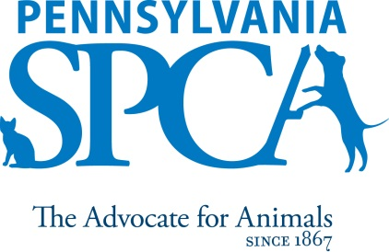
JOB DESCRIPTION

Animal Care Attendant

Implemented 10 /15, revised 9/19 FLSA Status: Non-Exempt

SUMMARY: The Animal Care Attendant is responsible for providing compassionate and attentive care to the entire population and maintaining a clean, healthy environment at all times.

PRINCIPAL DUTIES

- Perform daily cleaning of animal housing areas following the organizations written cleaning protocol.
- Provide daily feedings following the organization’s written feeding protocol.
- Follow written policies dictating proper handling techniques.
- Monitors both behavioral and medical well-being of the animals and immediately reports issues to the Animal Care Supervisor or Manager
- Assist with the transportation of shelter animals.
- Follow all daily schedule assignments and assist with other tasks as needed
- Maintain a healthy, clean, pleasant environment for the animals and the public.
- Treat all animals humanely, properly, and with compassion.
- Maintains a friendly demeanor and providing good customer service while assisting the public

EDUCATIONAL REQUIREMENTS
- High school graduation
- Two years of animal handling skills preferred
- Valid Driver’s license preferred
EXPERIENCE, ABILITIES AND QUALITIES REQUIRED
- Strong interpersonal skills and the ability to get along well with a variety of people.
- Strong problem solving skills – focusing on finding solutions to challenges.
- Able to remain calm even in stressful situations.
- Able to ask appropriate questions to gather information.
- Flexibility to manage multiple tasks.
- Knowledge of animal behavior and common medical conditions (or a willingness to gain this knowledge.)
- Comfort in working with animals of unknown disposition and those who may exhibit medical and other problems, as well as aggressive tendencies.
- Ability to lift and move objects and animals weighing up to 50 pounds for short distances and to humanely restrain an animal when necessary.
- Must have a sincere interest in the work, programs, and mission of the Pennsylvania SPCA
IMMEDIATE SUPERVISOR: Supervisor of Animal Care
HOURS FLSA STATUS: NON EXEMPT POSITION Minimum of 10 hours per day, 40 hours per week. Daily morning and afternoon hours and days of the week may vary according to the needs of the department schedule. Position will include weekends, nights and holidays.
INTRODUCTORY ASSESSMENT PERIOD The introductory assessment period runs from the date of hire for three months thereafter. For employment in any position with the Pennsylvania SPCA, this introductory assessment period is the period during which the specifics of the job are learned. During this period, either the employee or the Pennsylvania SPCA may end the employment relationship without notice or prejudice.
EMPLOYMENT There is no minimum period of employment guaranteed or implied by acceptance of an employment offer. It is the policy of Pennsylvania SPCA that even exempt positions are governed by the needs of the agency, which means that employment is for no specified term and either the Pennsylvania SPCA or the employee, may terminate that employment at any time. The Chief Executive Officer has final authority over these decisions and determinations.

