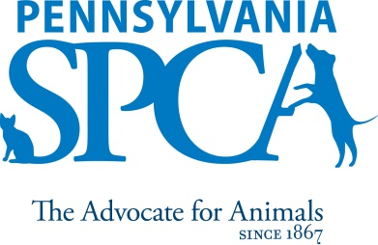
Essential Capabilities of Pennsylvania SPCA Volunteers
Volunteering to help homeless animals is very rewarding, but can also bring on some challenges. Listed below are the essential abilities a volunteer needs in order to safely participate in our volunteer program. However, there may be some opportunities for those who meet some requirements, but not others. If the areas you have chosen for volunteer activities are not compatible with your abilities, you may be reassigned to another area or you may not be able to volunteer with us.
Essential Physical Capabilities
- Ability to see and move safely throughout the building, distinguish animal body language and read instructions.
- Ability to travel unaided on varied surfaces; inside and outside of building.
- Ability to bend and squat in order to leash/harness and pick up an animal.
- High level of dexterity to leash/harness animals.
- Ability to stand for significant periods of time while walking dogs, assisting the public with visits, or cleaning cages/kennels.
- Ability to hear if animal is growling or making sounds indicating fear or pain.
- Ability to effectively communicate verbally, as well as in written form.
- Ability to cope with a very loud environment due to animal noises.
- Ability to work in the presence of peanut butter, cat, dog and small animal dander as well as cleaning chemicals
- Ability to push carts of laundry; load and unload washer and dryer; fold clean laundry and put away.
- Ability to wash dishes and put away; use sanitizer properly and read directions when necessary.
Essential Cognitive Capabilities
- Ability to understand, remember and follow both verbal and written instructions and procedures.
- Basic reading, writing, spelling and communication skills.
- Possess problem-solving capability.
- Ability to recognize potentially dangerous situations.
- Ability to understand safeguard against the risk of exposure to zoonotic diseases such as ringworm, or animal bites.

Essential Emotional Capabilities
- Ability to handle constructive criticism.
- Ability to remain calm and maintain a positive attitude.
- Ability to cope with a highly emotionally charged environment with some animals that are homeless, abandoned and/or abused, as well as the reality that some of the animals in our care may be euthanized.
- Ability to understand PSPCA policies and positions regarding companion animals, and other key animal welfare issues and an ability and willing ness to appropriately and accurately represent those policies when interacting with the public or otherwise representing PSPCA.
Level of supervision
- Once trained, must be able to work with minimal supervision, yet must recognize limitations in knowledge and abilities and ask for help when needed.
- If lacking the ability to work independently, must be able to work alongside a trained parent or guardian in an appropriate job, as determined by the volunteer department.
- Should be able to work independently for long periods of time, as well as work within a team atmosphere with other volunteers or staff.
Please indicate any reasonable accommodation you may need in order to meet the essential capabilities of your volunteer position at PSPCA”
________________________________________________________________________________________________________________________________________________________________________________________________________________________________________________________________________________________________________________________________________________________________________

____________________________________ ____________________________________
Volunteer Date

_____________________________________ ____________________________________
Volunteer Manager/Trainer Date

