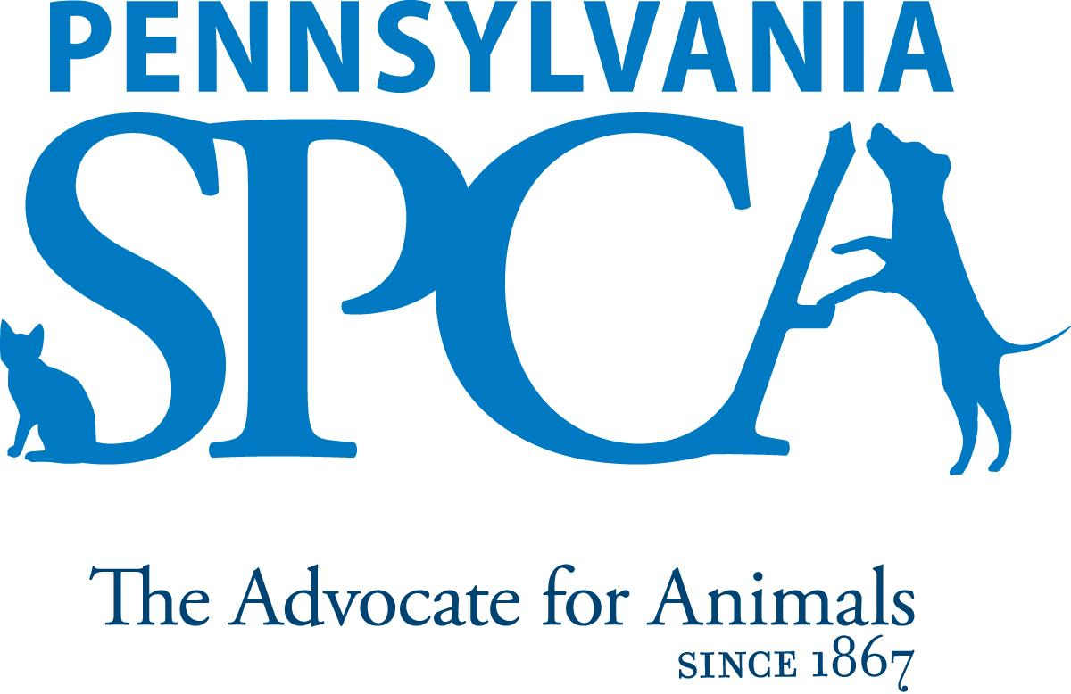
JOB DESCRIPTION

DEVELOPMENT DIRECTOR

The Pennsylvania SPCA is a non-profit animal welfare organization founded in 1867. Our
mission is to protect animals, prevent cruelty and improve the health and quality of life for
animals in Pennsylvania.

FLSA Status: Exempt

Work Schedule: Hybrid

SUMMARY: The Development Director is an integral part of the development team at the
Pennsylvania SPCA. Reporting to the Chief Development Officer, the Development
Director will have three primary responsibilities (1) overseeing the efficient operation of the
Development Team, (2) securing and stewarding donor support at all levels (3) working with the
team on corporate partnerships, events and grant funding.

DEVELOPMENT OPERATIONS TEAM MANAGEMENT
The Director will oversee the operations of the development office including but not limited to
incoming/outgoing mail processing, gift acknowledgement workflow, donor outreach, office
administration and meeting preparations. The Director will also ensure timely data reporting as needed. The Director will ensure proper engagement and recognition of the department’s volunteers.

DONOR MANAGEMENT
The Director will collaborate with the fund development team and programmatic staff to research and identify prospective funders, assist in the submission of compelling proposals, letters of intent, supporting documents, and interim and final reports.
Additionally, the Director will be responsible for a pipeline of donors and their cultivation, communication and engagement.

CORPORATE PARTNERSHIPS, EVENTS AND GRANTS
The Director will work closely with the CDO to identify, secure and steward corporate partners and sponsors in support of the PSPCA. This will include corporate research, preparing presentations for meetings, and sending stewardship materials (written documents, videos and photographs) to corporate partners. The Director will work with the PR and Communication Team to properly acknowledge corporate and funder partnerships on the website and in the media. The Director will work as part of a team to execute major events as needed.

CANDIDATE PROFILE
This team member must have excellent management skills with the ability to motivate a team,
adhere to deadlines and effectively problem solve. A broad base of fundraising experience will be well-utilized in supporting a complex portfolio of funding sources and relationships. Writing, grammar, research, proofreading, and copy- editing skills are required. They also must possess excellent attention to detail in crafting funder and donor communication, including acknowledgement letters, narratives, budgets, program evaluations, grant reports, and other documents as needed. They are able to plan, organize, and lead multiple projects, establish priorities and work collaboratively to grow fundraising for the PSPCA.

EXPERIENCE, ABILITIES AND QUALITIES REQUIRED:
- Prior management experience required
- Minimum three years grant writing experience (preferred)
- Thorough knowledge of the fundraising landscape and a proven track record of success
- Excellent written and verbal communication skills. Must be able to work with members
- from all across the organization.
- Effective research skills
- Excellent time-management skills/ multitasking
- Organized with high attention to detail
- Ability to perform well under pressure
- Ability to work both as a member of a team and independently with minimal supervision
- Ability to maintain confidentiality and work with a wide range of people
- Experience with Raiser’s Edge (preferred)
- Proficient with Microsoft Word, Excel and internet research
- Performs other duties as needed pertaining to the Development Department, and the larger organization as a whole.
- Ability to be on call.
- Interest in current animal welfare issues and promoting the PSPCA’s lifesaving mission
- Ability to effectively communicate the rationale for PSPCA policies and procedures
- Must have a sincere interest in the work, programs and mission of the PennsylvaniaSPCA.

EDUCATIONAL REQUIREMENTS:
- College degree preferred.
- Minimum of three years of related experience.
IMMEDIATE SUPERVISOR CDO
HOURS FLSA STATUS: EXEMPT POSITION Minimum of 8 hours per day, 40 hours per week. Daily hours and days of the week may vary according to the needs of the department schedule. Includes weekends, night, holiday and on-call work
INTRODUCTORY ASSESSMENT PERIOD The introductory assessment period runs from the date of hire for ninety days thereafter. For employment in any position with the Pennsylvania SPCA, this introductory assessment period is the period during which the specifics of the job are learned.
EMPLOYMENT There is no minimum period of employment guaranteed or implied by acceptance of an employment offer. It is the policy of Pennsylvania SPCA that even exempt positions are governed by the needs of the agency, which means that employment is for no specified term and either the Pennsylvania SPCA or the employee, may terminate that employment at any time. The Chief Executive Officer has final authority over these decisions and determinations.

