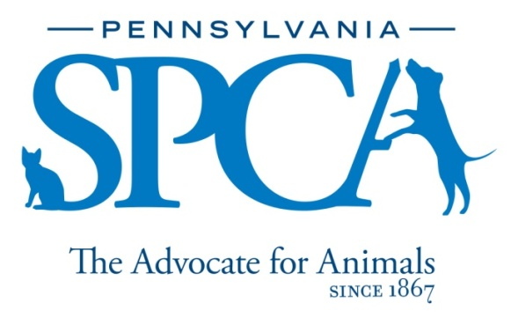
JOB DESCRIPTION
Humane Litigation and General Counsel Legal Intern
LOCATION: PSPCA Headquarters at 350 E. Erie Ave., Philadelphia, PA 19134/REMOTE
FULL TIME/PART TIME
DESCRIPTION: The PSPCA, headquartered in Philadelphia, is a non-profit organization dedicated to rescuing animals from abuse and neglect, providing lifesaving care and treatment, and reducing pet overpopulation through low-cost spay and neuter services. PSPCA is the second-oldest humane organization in the U.S., and the largest in Pennsylvania. All PSPCA programs are 100% donor funded.
The Humane Litigation and General Counsel Legal Intern will work in conjunction with the Director of Humane Litigation and Humane Law Enforcement Department all phases of civil and criminal litigation, including drafting petitions and motions, reviewing search warrants and criminal complaints, research and writing, discovery, and observing hearings and trials in both criminal and civil court. The position will report to the Director of Humane Litigation and General Counsel. This position is unpaid.
RESPONSIBILITIES:
The Humane Litigation and General Counsel Legal Intern will be responsible for the following:
- Draft Motions and Petitions relating to the forfeiture of animals in protective custody
- Review search warrants and criminal complaints
- Conduct legal research relative to animal cruelty investigations and prosecutions
- Conduct legal research relative to organizational issues including employment, contract, and civil litigation
- Assist in trial preparation for animal cruelty prosecutions
- Assist with case tracking and discovery
- Attend and observe court proceedings including hearings, motions, and trials
- Assist forensic team in tracking evidence
- Other duties as assigned

QUALIFICATIONS:
- Completed one or more years of law school
- Interest and/or experience in animals and animal welfare
- Interest and/or experience working in prosecutor’s office
- Interest and/or experience working in an in-house legal department
- Excellent organizational skills and attention to detail
- Ability to maintain confidential communications
- Good communication skills
- Sincere interest in the work, programs, and mission of the PSPCA

