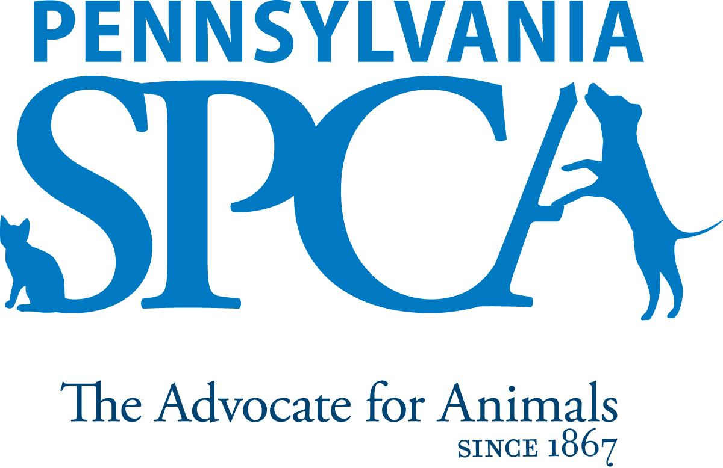
JOB DESCRIPTION
Manager of Special Events
SUMMARY This position is responsible for the successful execution of key development events (including but not limited to Tails & Trails 5k Race, Springer Golf Outing, and Bark & Whine Gala. It is the responsibility of this position to support the team and Chief Development Officer in the planning of all aspects of the event as well as management of all day-of logistics. This position also requires the manager to help identify and prepare solicitation and collateral materials for corporate and private supporters of the events. This position works closely with the Development, Communications and Marketing teams.
PRINCIPAL DUTIES
Event Logistics & Management
- Support the Chief Development Officer with the planning process for Development Events. This includes, but is not limited to, developing and managing event timelines, partnerships, budgets and task lists. This pertains to (but not limited to):
- Event mailings & event collateral
- Partnerships with vendors and facilities (both onsite and offsite)
- Solicit and secure Gifts-in-Kind for event auctions and underwriting. Ensure timely recognition of donor and proper tracking in systems
- Coordinate and execute event set-up and breakdown (being present for both of these)
- Prepare and coordinate permits and contracts
- At peak times work extended hours, including evenings and weekends
- Support the Chief Development Officer in prep/follow up for Co-Chair and Committee meetings
- Participate in the Reporting and Data Collection for Development’s events including
- Track and Report revenue and expenses for all events to adhere to all budgets
- Prepare check requests to process payments
- Prepare timely acknowledgement letters with the guidance of the Chief Development Officer
- Maintain donor records as they apply to event attendance, contributions, auctions, etc.
- Serve as the Coordinator of the committee meetings with the guidance of the CDO:
- Schedule meetings and track attendance
- Help with the preparation, distribution and printing of Board Decks and other materials
- Set up and Break down meeting spaces
- Distribute and collect other related materials and emails per CDO’s direction

- Other responsibilities and expectations
- Represent the Pennsylvania SPCA in a positive manner at all times, including working with staff, volunteers, vendors, donors and greater community.
- Coordinate volunteers for fundraising and cultivation events and thank event volunteers
Sponsorships
- Work with development team to create Sponsorship Packets for events
- Help identify potential corporate sponsors, set up meetings, and develop sponsorship packages to best match the companies’ missions and community engagement initiatives
- Form relationships with corporate sponsors to secure future investments and/or multi year sponsorships

EDUCATIONAL AND EXPERIENCE REQUIREMENTS Minimum qualifications:
- College degree
- Special event fundraising experience preferred
- Experience coordinating logistics and working with multiple partners to execute events
- Experience working with diverse groups of all backgrounds and ages is preferred.

KNOWLEDGE AND ABILITY REQUIREMENTS
- Excellent written and verbal communication
- Meticulous attention to detail
- Excellent organizational skills
- Ability to manage multiple priorities
- Ability to work nights/weekends/holidays
- Ability to be on call to answer off-site event questions
- Valid driver's license with clean driving record
- Interest in current animal welfare issues and promoting the PSPCA’s life saving mission
- Ability to perform well under pressure.
- Ability to organize, supervise and motivate volunteers.
- Experience and comfort in delivering presentations to a variety of different age groups.
- Must be able to work independently and be self-motivated.
- Ability to effectively communicate the rationale for PSPCA policies and procedures
IMMEDIATE SUPERVISOR CDO
HOURS FLSA STATUS: EXEMPT POSITION Minimum of 8 hours per day, 40 hours per week. Daily hours and days of the week may vary according to the needs of the department schedule. Includes weekends, night, holiday and on-call work
INTRODUCTORY ASSESSMENT PERIOD The introductory assessment period runs from the date of hire for ninety days thereafter. For employment in any position with the Pennsylvania SPCA, this introductory assessment period is the period during which the specifics of the job are learned.
EMPLOYMENT There is no minimum period of employment guaranteed or implied by acceptance of an employment offer. It is the policy of Pennsylvania SPCA that even exempt positions are governed by the needs of the agency, which means that employment is for no specified term and either the Pennsylvania SPCA or the employee, may terminate that employment at any time. The Chief Executive Officer has final authority over these decisions and determinations.

